What are Functional Skills?
Functional skills are essential abilities that are equivalent to GCSE level in the UK education system. These skills encompass fundamental life skills such as literacy and numeracy. Acquiring these skills is crucial not only for academic success but also for everyday tasks and activities. They play a significant role in helping individuals progress in their careers by enhancing their employability and job performance.
For those who may not have achieved their desired qualifications through traditional education routes, functional skills offer an alternative pathway to gaining recognised qualifications. These skills are practical and directly applicable to real-life situations, making them highly valuable in various professional settings. By honing these competencies, individuals can open up new opportunities for career advancement and personal development. Embracing functional skills can empower individuals to thrive in their chosen fields and achieve their goals.
Functional skills are becoming increasingly popular among home-schooled individuals who may not thrive in traditional school settings. These skills focus on practical applications of knowledge in areas such as English, mathematics. Unlike traditional academic subjects, functional skills emphasise real-world scenarios, problem-solving, and critical thinking.
Creating a high-quality personal tutoring program can greatly enhance educational opportunities for individuals who may not thrive in traditional school settings. By offering personalised attention and tailored learning experiences, tutors can help students reach their full potential. This approach is especially beneficial for those who may struggle in large classroom settings or have unique learning styles that require individualised support.

At Home Learning Hub, we are dedicated to fostering a nurturing learning environment that puts the child at the centre of the educational experience. By focusing on the individual needs and strengths of each student, we aim to empower them to succeed academically and personally. Our commitment to providing personalised care and attention ensures that every student feels supported and encouraged to reach their goals.
By prioritising the well-being and academic growth of each student, our team strives to create a positive and effective learning environment that fosters success. We believe that by offering best practice personal tutoring, we can help students unlock their full potential and achieve academic success in a way that is tailored to their unique needs and learning styles.
One of the key advantages of functional skills is their relevance to everyday life and work environments. They equip learners with the ability to apply their knowledge in practical situations, enhancing their employability and adaptability in a rapidly changing job market. Additionally, functional skills can be tailored to individual
needs and interests, providing a more personalised and engaging learning experience compared to a one-size-fits-all approach.
Overall, the rise in popularity of functional skills reflects a shift towards a more holistic and skills-based approach to education. By focusing on practical competencies that are essential for success in various aspects of life, functional skills offer a valuable alternative for those seeking a more hands-on and applicable educational experience.

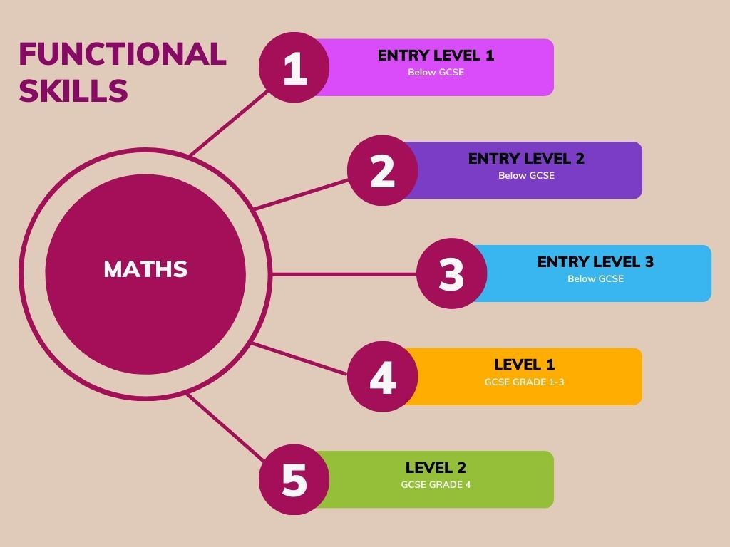 | 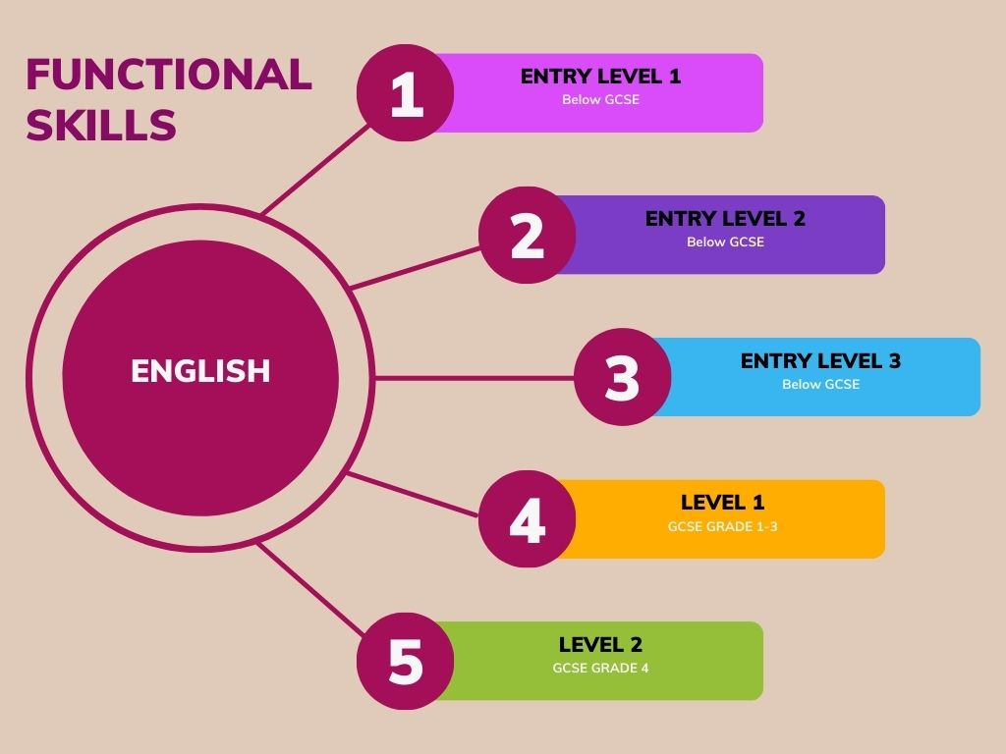
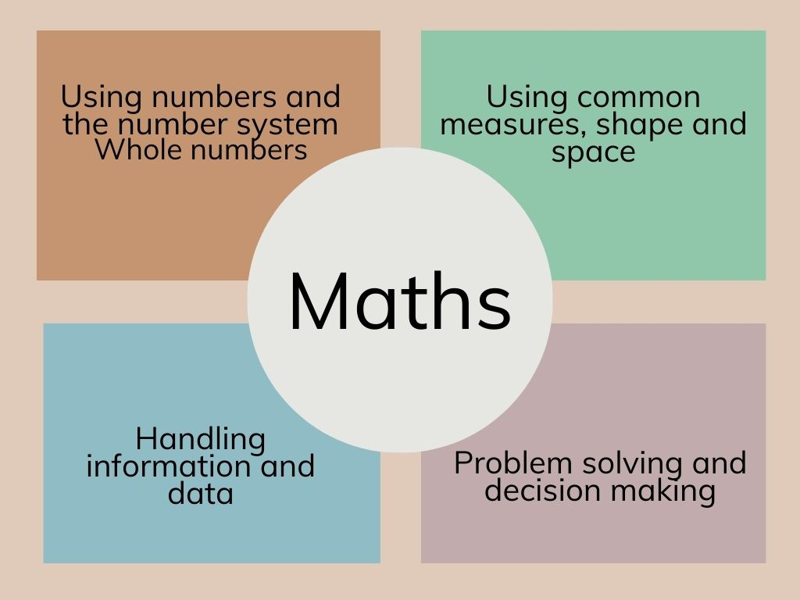 | 