This form should be used to log any medicines that have been given while providing care for pupils.
Home Learning Hub Medicine Log
Pupil’s Name: | DOB: | 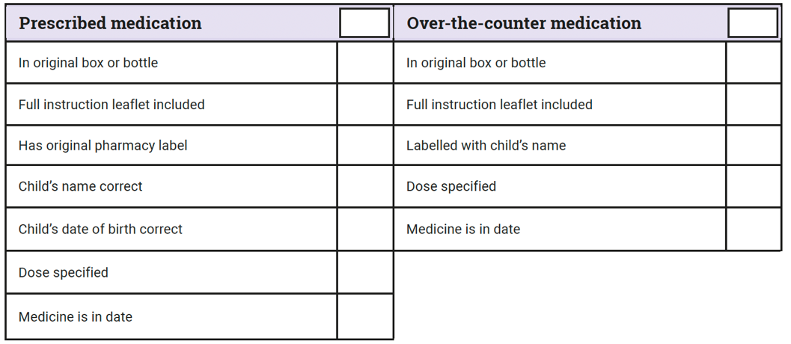
Date and Time:
Name of medication: | Storage:
Reason of requiring medication:

Dosage and frequency:
Parent’s Name: | Practitioner’s Name: | 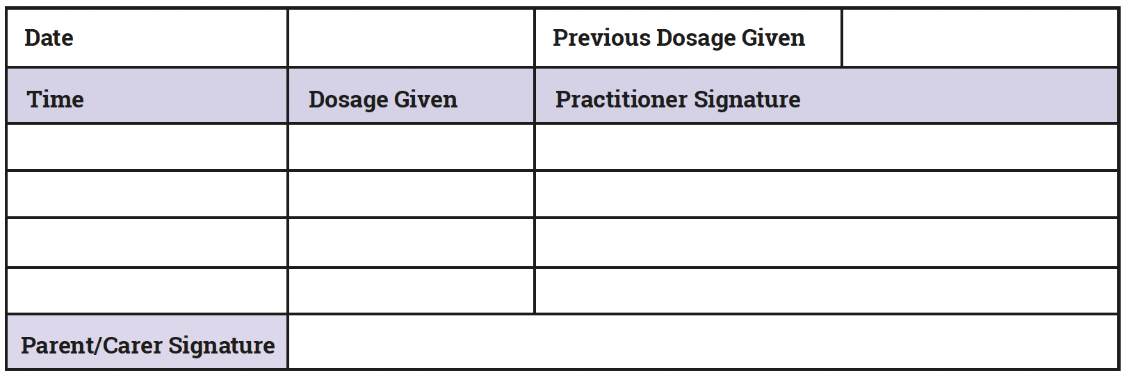
I confirm that the medication supplied is in the original container. I confirm that my child has already had previous doses of this medication and has not suffered any untoward reactions. | Where there is a risk of overdose, parents/carers will be contacted prior to administration, to verify that the child has not had any previous doses at home that day.
I give consent for my childminder to administer the above medication, at the stated dosage and frequency, as and when required, to my child. I will inform the childminder of any doses given at home before arrival.

Signature: | Signature: | Date signed:
*All data complies with GDPR policy and is kept in a locked cabinet overnight.

