This form should be used to log any behaviour incidents that have happened while providing care for pupils. Records must be accurate and as complete as is reasonably possible. Allegations should be recorded and reported according to Hereford Learning Hub’s safeguarding policy and procedures. Records are to be retained until the pupil is 21 years and 3 months of age.
Home Learning Hub Accident Log
Pupil’s Name: | DOB: | Location and size of injury:  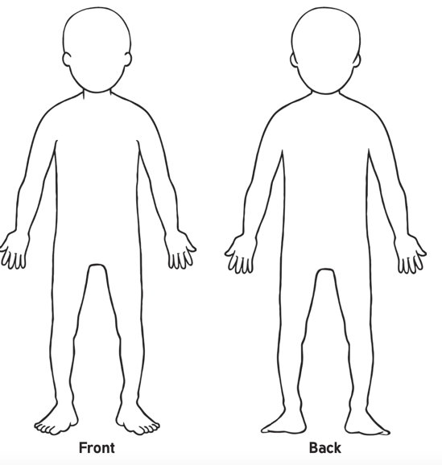
Date and Time:
Description of how the incident occurred: | Record of any injury and action taken:
Description of how the incident was handled: | Description of pupil after the incident:
Name of adult present: | Place incident occurred: | How was the information shred with the parent/carer?
First aid administered: Y/N | Condition of pupil following incident: | Paper/email/other?
Practitioner’s Name: | Signature: | Adult’s name:
Witness Name: | Signature: | Adult’s signature: | Date signed:
*All data complies with GDPR policy and is kept in a locked cabinet overnight.

